LLM-Based Intelligent Personal Finance Advisor with Personalized Savings Prediction and Investment Recommendation
K. Narasimha Sai, Ch. Srikar, D. Hari Haran, P.P. Jyothik Kshitij
Department of Computer Science and Engineering, Koneru Lakshmaiah Education Foundation, Andhra Pradesh, India
Supervisor: K. Swanthana
ARTICLE INFORMATION  Keywords:  Personal finance  Savings prediction  XGBoost  Large language model  Financial health  Investment recommendation | ABSTRACT  Personal financial management requires users to make continuous decisions involving income, expenditure, budgeting, savings and investment. Existing digital finance systems commonly provide transaction tracking, visualization, investment assistance or conversational guidance, but these capabilities are often implemented independently. This paper proposes an LLM-based intelligent personal finance advisor that combines Machine Learning (ML), financial analytics, market information and Large Language Model (LLM) interaction. An XGBoost regression model is designed to predict monthly savings from structured financial features. A financial-health module evaluates measurable indicators, an expense-analysis module identifies major spending categories, and an investment-analysis module considers available savings, risk preference and market context. The LLM converts structured analytical outputs into understandable personalized guidance rather than serving as the sole source of numerical financial decisions. A comparative review of research on ML in finance, LLMs in financial applications, ChatGPT-based investment advice, generative AI for retirement planning, personal-finance AI use and the WeFinance project identifies an integration gap across these capabilities. The contribution of this work is an end-to-end architecture connecting prediction, assessment, budgeting and investment-oriented explanation. Its superiority over baseline systems must be established through experiments; accordingly, this paper proposes an evaluation framework using prediction error, recommendation suitability, explanation quality and usability.  Keywords: Personal finance; savings prediction; XGBoost; large language model; financial health; investment recommendation.

1. Introduction
Personal finance is a multi-dimensional decision problem in which income, expenditure, savings, financial goals and investments influence one another. Conventional finance applications can record transactions and summarize historical behaviour, but users also need forward-looking estimates, financial-health assessment, budget improvement and investment guidance appropriate to their circumstances.
Machine Learning has been applied to financial prediction, portfolio management, risk analysis and other financial tasks. Nazareth and Reddy reviewed 126 articles across 44 journals and categorized applications that include stock markets, portfolio management, cryptocurrency, foreign exchange, financial crises and bankruptcy [1]. This broad review establishes the relevance of ML in finance but does not itself provide an integrated personal-finance advisor.
Large Language Models have introduced natural-language interaction and contextual explanation into financial applications. Surveys of LLMs in finance examine approaches such as prompting, domain-specific fine-tuning and financial reasoning, while also noting challenges involving data, computational cost, reliability and responsible deployment [2,5].
Research comparing ChatGPT with robo-advisors has examined whether recommendations align with investor profiles and benchmarks [3]. Work on generative AI and retirement planning highlights concerns about personalization, trustworthiness, domain expertise and regulatory oversight [4]. These findings suggest that an LLM should not be solely responsible for quantitative financial calculations.
This paper proposes a hybrid architecture in which XGBoost performs savings prediction, deterministic modules calculate financial indicators, market-data services provide current context, and an LLM explains the outputs in natural language. The intended contribution is the integration of these components into one personal-finance workflow.

2. Problem Statement
Existing financial applications and AI research often emphasize one or a subset of tasks, including expense tracking, forecasting, investment recommendations, financial chat or financial education. Users may therefore need multiple tools to understand current spending, estimate future savings, assess financial health and make informed investment decisions.
The problem addressed is how to combine ML-based savings prediction, financial-health assessment, expenditure analysis, market-aware investment analysis and LLM-based explanation into a unified and personalized decision-support system.

3. Objectives
- To integrate income and expenditure data to characterize users’ financial behaviour.
- To develop an XGBoost regression model for monthly savings prediction.
- To identify major expense categories and potential budget deviations.
- To calculate a Financial Health Score using measurable financial indicators.
- To generate investment-oriented insights using available savings, risk preference and market context.
- To use an LLM to explain analytical outputs in clear, personalized language.
- To evaluate the proposed system using predictive, recommendation and usability metrics.

4. Related Work

4.1. Financial Applications of Machine Learning: A Literature Review
Nazareth and Reddy [1] review 126 studies across 44 journals and describe ML and deep-learning applications in financial forecasting, stock markets, portfolio management and related areas. The work provides a broad map of financial ML research. Its scope is not an end-to-end personal finance application connecting individual savings prediction with budgeting, financial-health assessment and LLM-based advice.

4.2. Large Language Models in Finance: A Survey
Li et al. [2] examine the use of LLMs in financial tasks and approaches for applying pretrained models, including prompting and fine-tuning. This literature supports the potential of language models for financial text understanding and decision support, while underscoring issues of reliability and responsible use. It does not itself implement the proposed personal-finance pipeline.

4.3. Does ChatGPT Provide Better Advice Than Robo-Advisors?
Oehler and Horn [3] compare ChatGPT with robo-advisors for selected investor profiles and benchmark recommendations. The study provides evidence about LLM investment guidance in the tested scenarios. Its primary focus is investment advice, not continuous modelling of income, expenditure, monthly savings and overall financial health.

4.4. Can ChatGPT Plan Your Retirement?
Lo and Ross [4] discuss generative AI in financial advice and identify challenges around personalization, trustworthiness, domain knowledge and regulation. These concerns motivate a design where financial computations are performed by explicit models and rules, with the LLM used as an explanation layer.

4.5. A Survey of LLMs for Financial Applications
Nie et al. [5] survey LLM research in financial language tasks, sentiment analysis, financial time series, reasoning and decision support. The survey maps emerging applications and research challenges, but it is not itself an integrated personal-finance product.

4.6. Generative AI for Personal Financial Management
Research on how individuals use generative AI for personal financial management examines user adoption across tasks such as investment, savings planning and budget management [6]. Such work establishes practical relevance but studies user behaviour rather than implementing a predictive advisor that combines the proposed components.

4.7. WeFinance – AI-Powered Personal Finance Assistant
WeFinance is a practical AI personal-finance project documenting features such as bill/image understanding and conversational financial assistance. It demonstrates the value of an interactive finance assistant. Based on the documented project scope, personalized XGBoost-based monthly savings prediction is not established as its central feature; the proposed system makes savings prediction and financial-health assessment explicit components [7].

5. Comparative Analysis
Table 1 compares the primary focus of the selected works with the proposed architecture. The entries summarize documented emphasis; ‘not central’ does not imply that a work is incapable of supporting the function.
Work | Main emphasis | Savings prediction | Financial health | Expense/budget | Investment | LLM interaction
ML finance review [1] | Financial ML applications | Not personal focus | No integrated score | No integrated workflow | Domain coverage | No
LLMs in finance [2] | LLM finance survey | Not a system | No | Not central | Domain coverage | Yes
ChatGPT vs robo-advisors [3] | Investment advice | No | No | No | Yes | Yes
Retirement planning [4] | Advice reliability | No implementation | Not central | Not central | Advice context | Yes
LLM finance survey [5] | Research taxonomy | Research topic | Research topic | Research topic | Research topic | Yes
Personal finance AI use [6] | User behaviour | No predictive model | No integrated score | User task | User task | Yes
WeFinance [7] | AI finance assistant | Not central in docs | Not central in docs | Bill/finance insights | Documented advice | Yes
Proposed system | Integrated personal finance | XGBoost | Explicit score | Category and budget analysis | Market-aware guidance | Yes

6. Research Gap and Contribution
The reviewed literature shows substantial progress in financial ML, LLM-based financial interaction and investment recommendation. However, the selected works do not consistently integrate savings prediction, financial-health scoring, expense and budget analysis, market-aware investment context and personalized LLM explanation in one end-to-end workflow.
The proposed contribution is integration rather than the invention of a new standalone algorithm. It links the user's financial data to predicted savings, a measurable assessment of financial health, spending observations and investment-oriented insights. This makes it possible to connect budgeting decisions with the user's estimated ability to save and invest.
A further design contribution is the separation of computation from communication. XGBoost and deterministic financial rules generate numerical outputs, while the LLM explains these outputs. This structure is intended to make results more traceable than a workflow in which an LLM independently invents financial figures.

7. Proposed System and Methodology

7.1. Architecture
The proposed prototype uses React with Vite for the frontend, Python with FastAPI for the backend and SQLite for initial structured storage. The ML layer uses Pandas, NumPy, Scikit-learn and XGBoost. Market data may be retrieved using a provider such as yfinance, and an LLM API generates natural-language explanations.
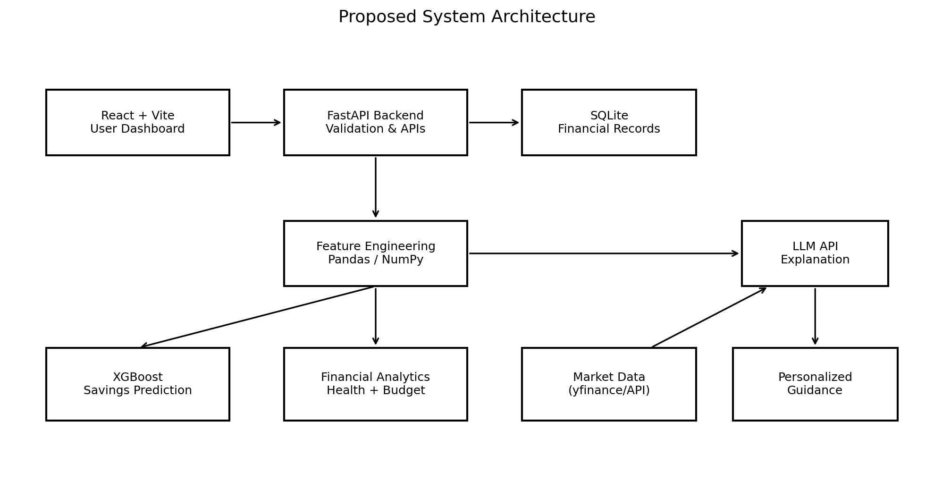
Fig. 1. Proposed system architecture.
The workflow is: user financial data → preprocessing and feature engineering → savings prediction → financial-health scoring → expense/budget analysis → investment analysis → LLM explanation → dashboard presentation.
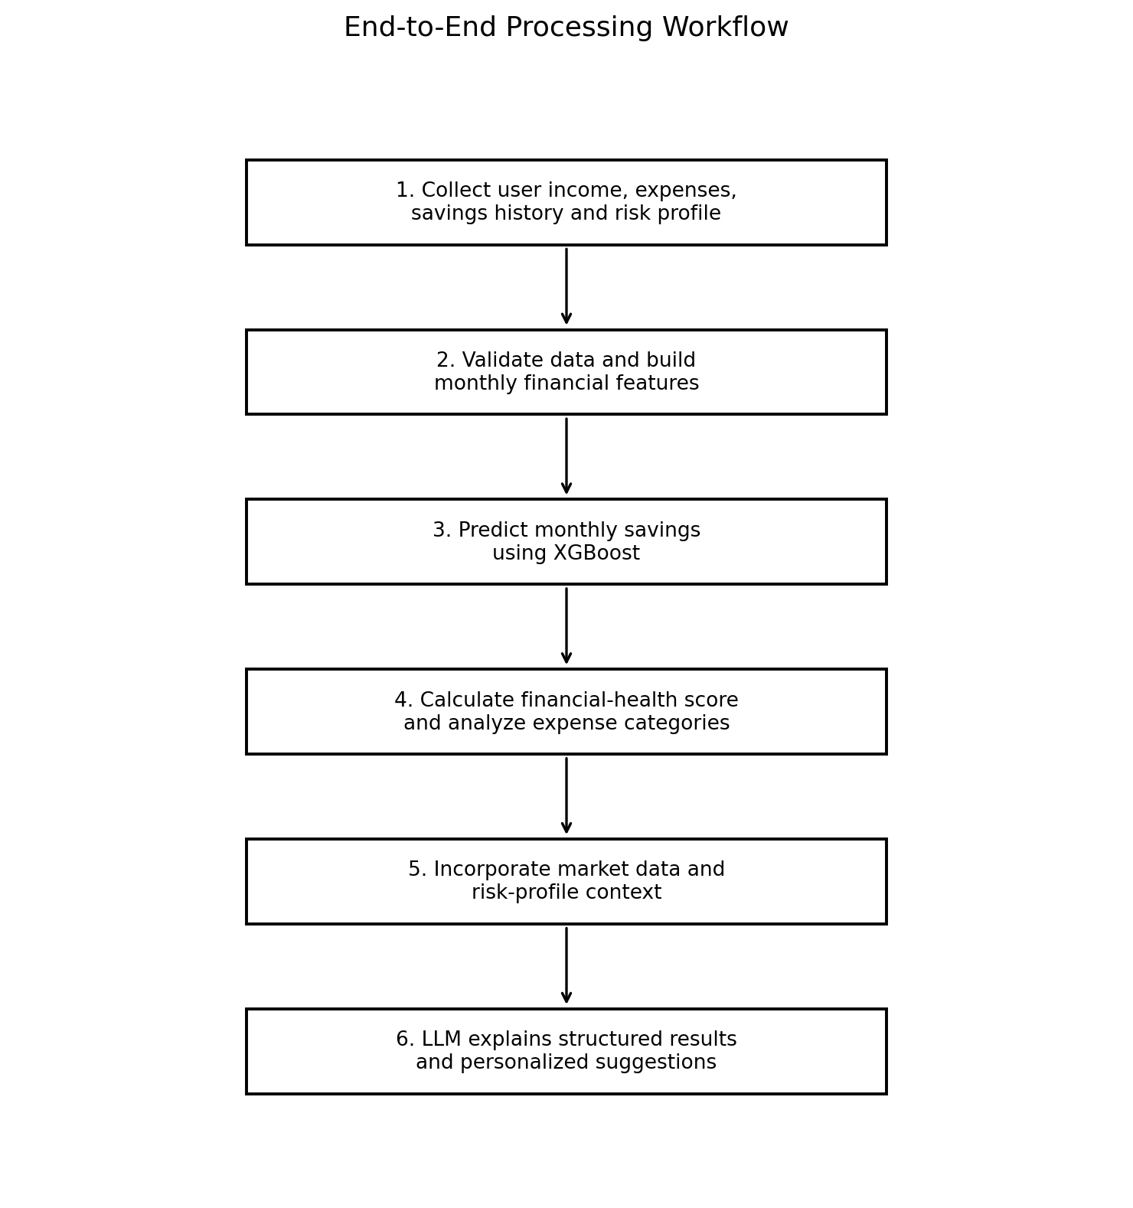
Fig. 2. End-to-end processing workflow.

7.2. Data Preparation and Features
Financial records are aggregated into monthly features such as total income, total expenses, essential expenses, discretionary expenses, recurring costs, previous savings and savings ratio. Data validation should check missing values, duplicate records, impossible amounts and inconsistent dates. Sensitive personal identifiers should be minimized or removed from model features.

7.3. XGBoost Savings Prediction
Monthly savings is the target variable. A feature vector X may contain income, expense categories, recurring expenses, prior savings and derived ratios. XGBoost regression learns a function ŷ = f(X), where ŷ is the estimated monthly savings. The dataset should be divided into training and test sets without leaking future information into training.
Model performance should be reported using Mean Absolute Error (MAE), Root Mean Squared Error (RMSE) and coefficient of determination (R²). Comparisons with a simple baseline, such as predicting the previous month's savings or using a linear regression model, are needed to establish whether XGBoost provides a measurable benefit.

7.4. Financial Health Score
The score can combine normalized indicators such as savings ratio, expense-to-income ratio and discretionary-spending ratio. The formula and thresholds must be explicitly documented, and the score should be presented as a transparent indicator rather than a formal credit rating or professional financial assessment.

7.5. Expense and Budget Analysis
The expense module groups transactions by category and compares spending with user-defined budget limits and income. It can flag categories that account for a large share of expenses or exceed a budget. Suggestions should be tied to observed data and should not label an expense unnecessary without adequate context.

7.6. Investment Analysis
The investment module considers available savings, user risk preference and current market context. Market prices and indicators should be timestamped and sourced. Recommendations should explain risk and uncertainty, avoid promises of returns and remain decision-support information rather than a substitute for regulated financial advice.

7.7. LLM-Based Explanation
The LLM receives structured outputs from the prediction, health-score, expense and market modules. It produces clear explanations and suggestions using those outputs as evidence. Prompts should instruct the model not to invent market prices or numerical results and to disclose when information is missing or stale.

8. Why the Proposed System Is Distinct
Integrated workflow. The system combines several financial tasks that the selected works mainly examine separately.
Forward-looking savings estimate. The XGBoost module adds a prediction component beyond retrospective expense summaries.
Quantitative and conversational components. Numerical outputs come from explicit models and rules; the LLM focuses on explanation.
Personalized guidance. Advice is conditioned on recorded income, expenditure, estimated savings and risk preferences.
Financial-health context. The system assesses the broader financial situation before presenting investment-oriented information.
Evaluable claims. Prediction, recommendation relevance and usability can be compared against baselines.

9. Experimental Evaluation Plan
The system's advantages should be verified empirically. No performance results are claimed in this paper because the completed model has not yet been evaluated.
Component | Metric | Purpose
Savings prediction | MAE, RMSE, R² | Quantify prediction error and fit
Financial health | Rule validation, consistency | Check score stability and transparency
Expense analysis | Budget deviation accuracy | Check identification of overspending
Investment guidance | Risk-profile alignment; expert review | Assess suitability of explanations
LLM responses | Factual consistency, relevance, readability | Assess explanation quality
Usability | Task completion, user questionnaire | Assess practical usefulness
An ablation study should compare (A) a rule-based financial assistant, (B) an LLM-only interface and (C) the proposed hybrid ML + analytics + LLM system. This would test whether integration improves prediction, personalization and explanation quality. A time-based split is preferable where records have a chronological order.
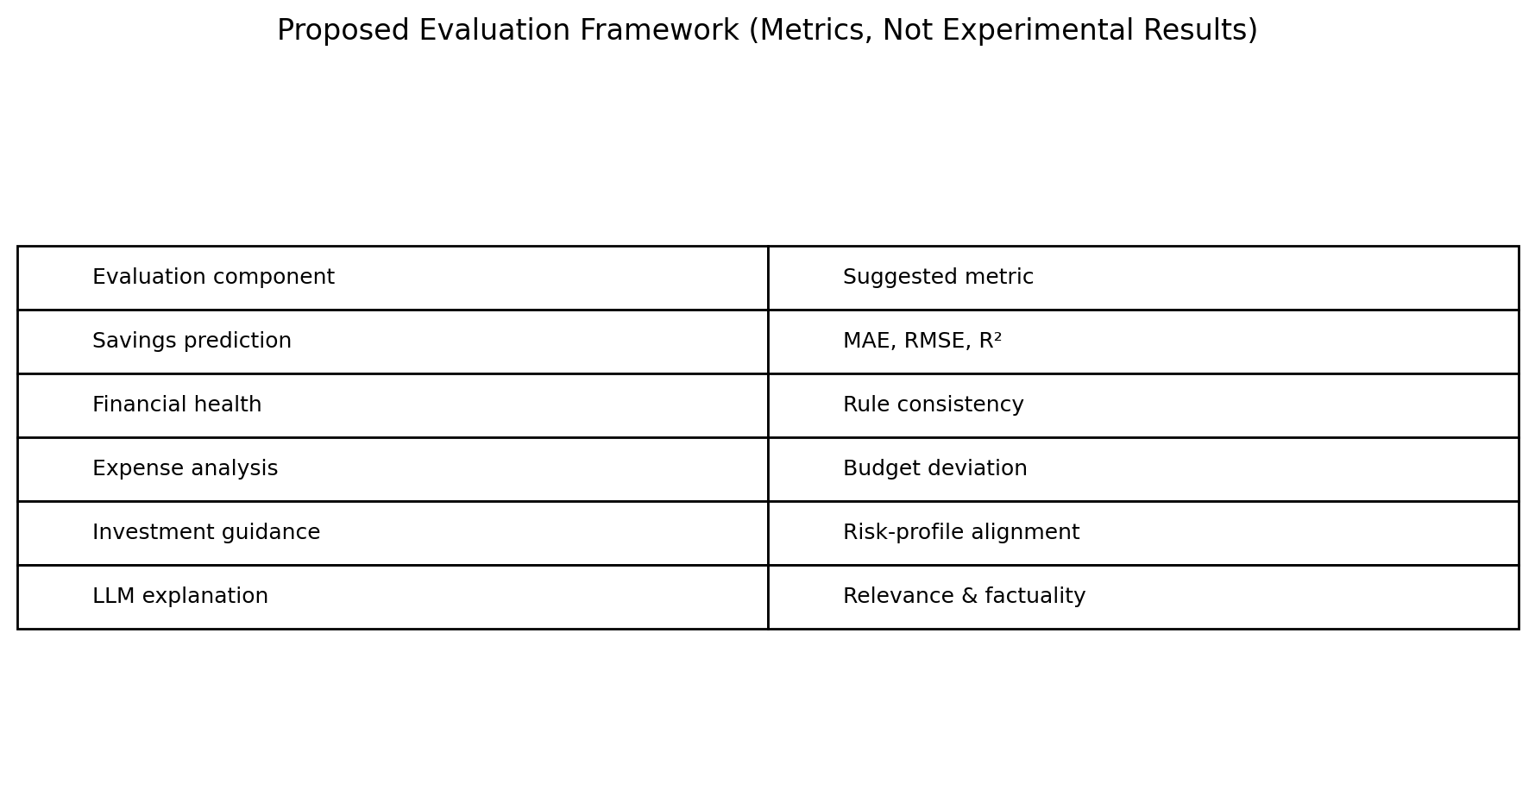
Fig. 3. Proposed evaluation framework; the table lists metrics to be measured, not achieved results.

10. Discussion
The reviewed work suggests that the opportunity lies in connecting established techniques rather than assuming that a single AI model can perform every financial task reliably. ML offers structured prediction, financial rules provide consistent calculations, market data provides time-sensitive context and LLMs offer a convenient interaction layer.
The proposed design can be more comprehensive than a single-purpose assistant because it connects financial state, predicted savings and investment context. Whether this results in greater accuracy or better user outcomes remains an empirical question and must be established with comparative evaluation.

11. Limitations and Responsible Use
Savings predictions depend on the quantity and representativeness of historical data. Market information changes rapidly, and past performance does not guarantee future returns. LLMs can produce incorrect explanations, and financial recommendations are sensitive to personal circumstances and applicable regulation. The system should be presented as a student research prototype and decision-support tool, not a replacement for a qualified financial professional.
User data must be protected, API credentials must not be committed to source control, and external LLM services should receive only the minimum information needed. Model limitations and the date of market data should be visible to users.

12. Conclusion
This paper proposed an LLM-based intelligent personal finance advisor combining XGBoost savings prediction, financial-health scoring, expense and budget analysis, market-aware investment analysis and LLM-based personalized guidance. The comparative review identifies an integration gap across the selected literature and practical projects. The proposed system's main contribution is a unified workflow that links a user's current financial behaviour with a savings estimate and understandable guidance.
The research position is strongest when framed as an integrated architecture rather than an unsupported claim of universal superiority. Future work should implement the complete pipeline, test alternative regression models, compare the system with appropriate baselines, conduct user evaluation and strengthen safeguards for privacy and reliable financial guidance.

References
[1] N. Nazareth and Y. V. R. Reddy, “Financial applications of machine learning: A literature review,” Expert Systems with Applications, vol. 219, 119640, 2023. doi: 10.1016/j.eswa.2023.119640.
[2] Y. Li, S. Wang, H. Ding, and H. Chen, “Large Language Models in Finance: A Survey,” Proceedings of the Fourth ACM International Conference on AI in Finance, pp. 374–382, 2023. doi: 10.1145/3604237.3626869.
[3] A. Oehler and M. Horn, “Does ChatGPT provide better advice than robo-advisors?,” Finance Research Letters, vol. 60, 104898, 2024. doi: 10.1016/j.frl.2023.104898.
[4] A. W. Lo and J. Ross, “Can ChatGPT Plan Your Retirement?: Generative AI and Financial Advice,” Harvard Data Science Review, Special Issue 5, 2024. doi: 10.1162/99608f92.ec74a002.
[5] Y. Nie et al., “A Survey of Large Language Models for Financial Applications: Progress, Prospects and Challenges,” arXiv:2406.11903, 2024.
[6] T.-Y. Pak, “How Individuals Use Generative AI for Personal Financial Management,” Journal of Behavioral and Experimental Finance, 2026. Verify final volume/article metadata against the publisher before submission.
[7] WeFinance, “AI-Powered Personal Finance Assistant,” project repository. Available: https://github.com/JasonRobertDestiny/WeFinance.

Author Note
This document follows the visual organization of the supplied journal article: centered title and affiliation, an article-information/abstract block, numbered sections, compact two-column body text, comparison tables and numbered references. It is a formatting adaptation, not an official Elsevier template or a reproduction of the source paper's content. Verify all bibliography metadata and add actual experimental results before submission.
Note: Performance graphs such as accuracy, MAE/RMSE comparison, ROC curves, or savings-prediction plots are not included as empirical results because the proposed system has not yet been run on a validated dataset. Such charts should be generated after model training and evaluation.

